Cheatsheet: Kubernetes commands
kubectl get pod: Get information about all running pods
kubectl describe pod <pod>: Describe one pod
kubectl expose pod <pod> --port=444 --name=frontend: Expose the port of a pod (creates a new service)
kubectl port-forward <pod> 8080: Port forward the exposed pod port to your local machine
kubectl attach <podname> -i: Attach to the pod
kubectl exec <pod> -- command: Execute a command on the pod
kubectl label pods <pod> mylabel=awesome: Add a new label to a pod
kubectl run -i --tty busybox --image=busybox --restart=Never -- sh: Run a shell in a pod - very useful for debugging
kubectl get deployments: Get information on current deployments
kubectl get rs: Get information about the replica sets
kubectl get pods --show-labels: get pods, and also show labels attached to those pods
kubectl rollout status deployment/helloworld-deployment: Get deployment status
kubectl set image deployment/helloworld-deployment k8s-demo=k8s-demo:2: Run k8s-demo with the image label version 2
kubectl edit deployment/helloworld-deployment: Edit the deployment object
kubectl rollout status deployment/helloworld-deployment: Get the status of the rollout
kubectl rollout history deployment/helloworld-deployment: Get the rollout history
kubectl rollout undo deployment/helloworld-deployment: Rollback to previous version
kubectl rollout undo deployment/helloworld-deployment --to-revision=n: Rollback to any version version

What is Kubernetes?
Kubernetes is an open source Orchestration system for Docker Containers. Kubernetes is a platform that eliminates the manual processes involved in deploying containerized applications
It is a container management system developed in the Google platform. It helps you to manage a containerized application in various types of Physical, virtual, and cloud environments.
- It lets you to schedule containers on a cluster of machines
- You can run multiple containers on one machine.
- You can run long running services (like web applications)
Kubernetes will manage the state of these containers
- Can start the container on specific nodes
- Will restart a container when it get killed
- Can move containers from one node to another node.
Instead of just running a few docker containers on one host manually, Kubernetes is a platform that will manage the containers for you.
Kubernetes clusters can start with one node until thousands of nodes.
Popular docker orchestrators are – Docker Swarm , Mesos

Why use Kubernetes?
- Kubernetes can run on-premises bare metal, OpenStack, public clouds Google, Azure, AWS, etc.
- Helps you to avoid vendor lock issues as it can use any vendor-specific APIs or services except where Kubernetes provides an abstraction, e.g., load balancer and storage.
- Containerization using kubernetes allows package software to serve these goals. It will enable applications that need to be released and updated without any downtime.
- Kubernetes allows you to assure those containerized applications run where and when you want and helps you to find resources and tools which you want to work.

Features of Kubernetes
- Automated Scheduling
- Self-Healing Capabilities
- Automated rollouts & rollback
- Horizontal Scaling & Load Balancing
- Offers environment consistency for development, testing, and production
- Infrastructure is loosely coupled to each component can act as a separate unit
- Provides a higher density of resource utilization
- Offers enterprise-ready features
- Application-centric management
- Auto-scalable infrastructure
- You can create predictable infrastructure

- Automated Scheduling: Kubernetes provides advanced scheduler to launch container on cluster nodes based on their resource requirements and other constraints, while not sacrificing availability.
- Self Healing Capabilities: Kubernetes allows to replaces and reschedules containers when nodes die. It also kills containers that don’t respond to user-defined health check and doesn’t advertise them to clients until they are ready to serve.
- Automated rollouts & rollback: Kubernetes rolls out changes to the application or its configuration while monitoring application health to ensure it doesn’t kill all your instances at the same time. If something goes wrong, with Kubernetes you can rollback the change.
- Horizontal Scaling & Load Balancing: Kubernetes can scale up and scale down the application as per the requirements with a simple command, using a UI, or automatically based on CPU usage

Kubernetes Architecture:
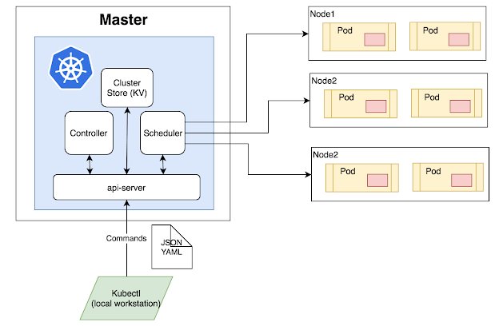
Kubernetes Architecture has the following main components:
- Master nodes
- Worker/Slave nodes

Master Node
The master node is responsible for the management of Kubernetes cluster. It is mainly the entry point for all administrative tasks. There can be more than one master node in the cluster to check for fault tolerance.
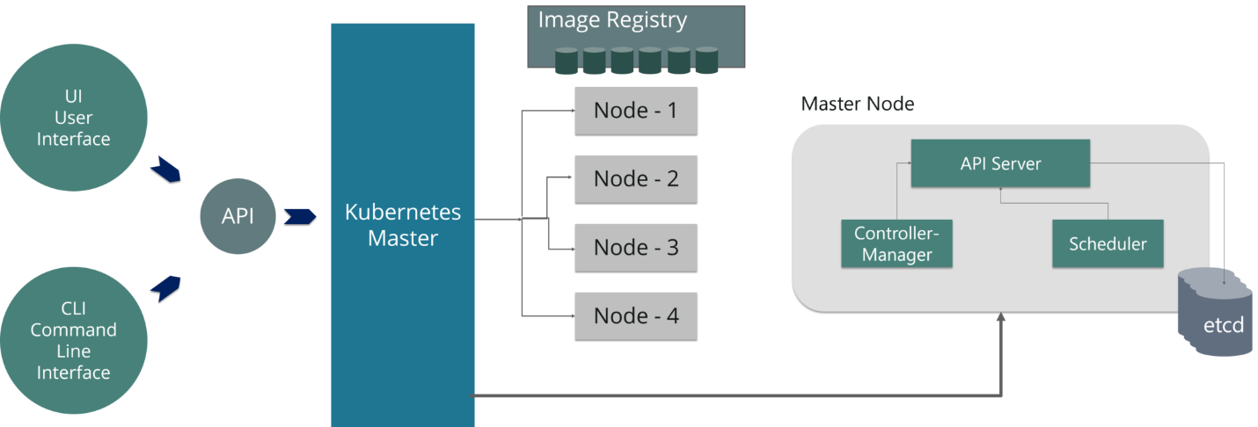
The master node has various components like API Server, Controller Manager, Scheduler, and ETCD.
- API Server: The API server is the entry point for all the REST commands used to control the cluster. Kubeconfig is a package along with the server side tools that can be used for communication. It exposes Kubernetes API.
- Controller Manager: Is a daemon that regulates the Kubernetes cluster, and manages different non-terminating control loops. It is responsible for collecting and sending information to API server. It works toward getting the shared state of cluster and then make changes to bring the current status of the server to the desired state.
- Scheduler: The scheduler schedules the tasks to slave nodes. It stores the resource usage information for each slave node. It is responsible for distributing the workload. It also helps you to track how the working load is used on cluster nodes. It helps you to place the workload on resources, which are available and accept the workload.
- ETCD: It stores the configuration information, which can be used by each of the nodes in the cluster. It is a high availability key value store that can be distributed among multiple nodes. It is accessible only by Kubernetes API server as it may have some sensitive information. It is a distributed key value Store which is accessible to all.

Worker/Slave nodes
Worker nodes contain all the necessary services to manage the networking between the containers, communicate with the master node, and assign resources to the scheduled containers. The worker node has various components as below
- Docker Container: Docker runs on each of the worker nodes, and runs the configured pods
- Kubelet: Kubelet gets the configuration of a Pod from the API server and ensures that the described containers are up and running. It interacts with etcd store to read configuration details and wright values. This communicates with the master component to receive commands and work. The kubelet process then assumes responsibility for maintaining the state of work and the node server. It manages network rules, port forwarding, etc.
- Kube-proxy: Kube-proxy acts as a network proxy and a load balancer for a service on a single worker node. This is a proxy service which runs on each node and helps in making services available to the external host. It helps in forwarding the request to correct containers and is capable of performing primitive load balancing. It makes sure that the networking environment is predictable and accessible and at the same time, it is isolated as well. It manages pods on node, volumes, secrets, creating new containers’ health checkup, etc.
- Pods: A pod is one or more containers that logically run together on nodes.

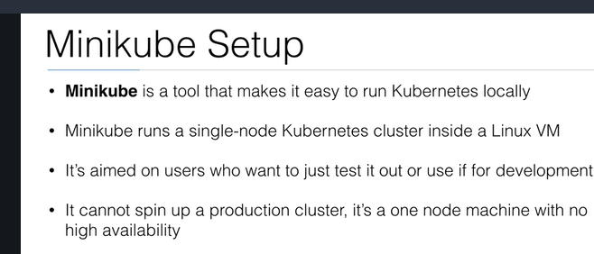

Installation of Minikube on EC2 Ubuntu1. Run a public EC2 Server with the following setup
AMI | Ubuntu Server 18.04 LTS (HVM), SSD Volume Type
Instance Type | t3.micro (2 vCPU, 1GB Memory)
Storage | 8 GB (gp2)
Tags | – Key: Name  – Value: Minikube
Security Group | Name: Minikube Security Group  – SSH, 0.0.0.0/0  Later we will be editing this.
Key Pair | Create your own keypair.  You will need this to SSH to your EC2 Instance
Update: I changed the Instance Type from t2.micro (1 vCPU) to t3.micro (2 vCPU). An update to Minikube required a minimum of 2 vCPUs. The error when running with t2.micro was Requested cpu count 1 is less than the minimum allowed of 2.
t3.micro is no longer in the Free Tier, make sure to stop or terminate the instance after you are done testing to avoid a huge AWS bill.
Thank you to everyone in the comments section who pointed this change.

2. SSH into your created EC2 Instance using your keypair.
ssh ubuntu@<ipv4_public_ip> -i <keypair>.pem

3. Install kubectl
curl -LO https://storage.googleapis.com/kubernetes-release/release/`curl -s https://storage.googleapis.com/kubernetes-release/release/stable.txt`/bin/linux/amd64/kubectl
chmod +x ./kubectl
sudo mv ./kubectl /usr/local/bin/kubectl

4. Install Docker
sudo apt-get update && \
sudo apt-get install docker.io -y
Minikube requires Docker.

5. Install Minikube
curl -Lo minikube https://storage.googleapis.com/minikube/releases/latest/minikube-linux-amd64 && chmod +x minikube && sudo mv minikube /usr/local/bin/

6. Check Minikube Version
minikube version
We have now successfully installed Minikube!
Let’s test it!

Running Minikube on EC2 Ubuntu
Become a root user.
sudo -i
If you are not comfortable running commands as root, you must always add sudo before the commands minikube and kubectl.

2. Start Minikube
minikube start --vm-driver=none
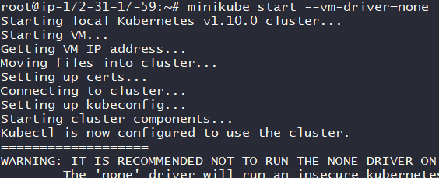
Do not worry about the warning. As long as you see the message ‘Kubectl is now configured to use the cluster.’ you have successfully ran Minikube.
Note: In the Install Minikube documentation from Kubernetes.io it says that you need to enable virtualization by accessing the computer’s BIOS. For EC2 Instances we do not have access to the BIOS since AWS EC2 instance is a Virtual Machine. Thus we are using the --vm-driver=none tag. No need to install a Hypervisor (VirtualBox or KVM)

3. Check the status of Minikube
minikube status
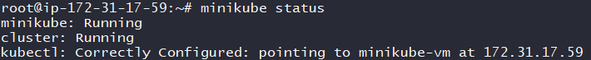
If you see the status as ‘running’ then we can now run kubectl commands.

4. Let us run our first container
kubectl run hello-minikube --image=gcr.io/google_containers/echoserver:1.4 --port=8080
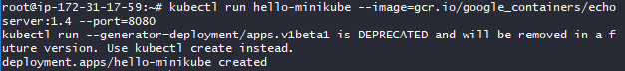

5. Expose the container ports so that we can access it.
kubectl expose deployment hello-minikube --type=NodePort

6. Find where port 8080 in container exposed in EC2 Instance port.
kubectl get services
Note: Port 30263 is the EC2 Instance Port where the Port 8080 of the container is exposed.
The EC2 Instance Port changes each time you expose a port, you may have been given a different value than what I have.
kubectl get services command shows the list of services and their exposed ports.
Let us check by accessing this via a web browser on our local computer. But first we need to edit our EC2 Security Group.

7. Edit Security Group of the EC2 Instance to be access
The goal is for us to be able to access the EC2 Instance Port (30263 for me) via the internet.
EC2 >> (Network & Security) Security Groups >> Minikube Security Group >> Ingress
Press Edit. Then Add Rule.
Add the following.
Type | Custom TCP Rule
Protocol | TCP
Port Range | 30263 (the port given to you by the kubectl get services command)
Source | Custom  0.0.0.0/0 (Accessible via the internet)
Click Save.
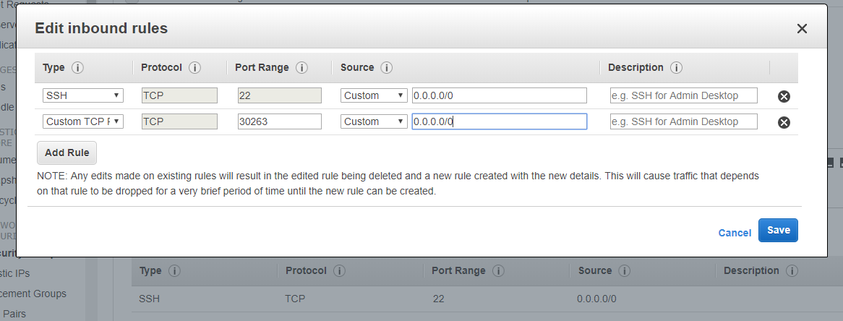

8. Access the our container via the EC2 Instance Port on a web browser.
The address is <ipv4_public_ip>:<ec2_port>.
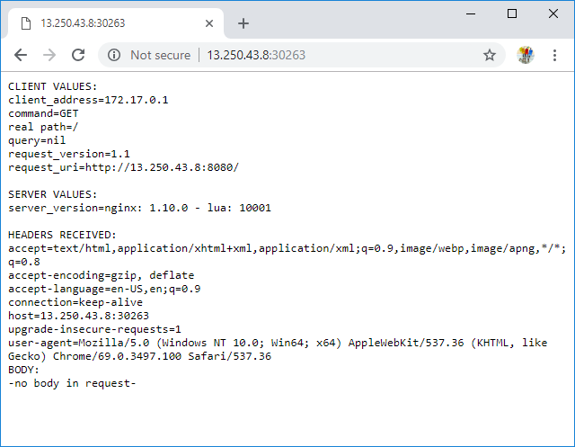
My EC2 Instance has an IPv4 Public IP of 13.250.43.8. And since my hello-minikube port 8080 is exposed on port 30263, the address that I placed on my browser is 13.250.43.8:30263.
See the request_uri of the page displayed by the web browser, it says that I am accessing via port 8080.
I accessed my container deployment using Chrome on my laptop. You can use any web browser you like (Safari, Internet Explorer, Edge, Firefox, etc.)
Now that we know that we can access our container, let us finish this and clean up.

9. Delete the exposed service (port)
kubectl delete services hello-minikube

10. Delete the deployed container (hello-minikube)
kubectl delete deployment hello-minikube

11.Stopping Minikube/Shutting Down the Cluster
minikube stop
https://dreamcloud.artark.ca/docker-hands-on-guide-docker-and-minikube-on-aws-ec2/
Install Minikube in Linux:
Minikube is a free and open source tool that enables you to set up single node Kubernetes cluster inside your Linux system. Minikube can be installed on Linux, MacOS and Windows Operating system. Minikube also supports various Kubernetes features such as NodePorts, DNS, Container Network Interface, Ingress, ConfigMaps, Secrets and much more.

Step 1 - Update system
apt-get update -y
apt-get upgrade -y

Step 2 - install some required packages with the following command
apt-get install curl wget apt-transport-https -y

Step 3 - Install VirtualBox Hypervisor
Minikube supports both KVM and VirtualBox hypervisor. So, you will need to install VirtualBox or KVM to your system.

apt-get install virtualbox virtualbox-ext-pack

Step 4 - Install Minikube
wget https://storage.googleapis.com/minikube/releases/latest/minikube-linux-amd64

Once the download is completed, copy the downloaded file under /usr/local/bin with the following command:
cp minikube-linux-amd64 /usr/local/bin/minikube

Next, give execution permission to the minikube with the following command
chmod 755 /usr/local/bin/minikube
Next, check the version of Minikube with the following command
minikube version

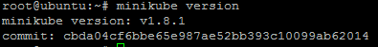

Install Kubectl :-
Kubectl is a tool to deploy and manage applications on Kubernetes. By default, Kubectl is not available in the Ubuntu 18.04 default repository.

First, download and add the GPG key with the following command

curl -s https://packages.cloud.google.com/apt/doc/apt-key.gpg | apt-key add -

add Kubernetes apt repository with the following command

echo "deb http://apt.kubernetes.io/ kubernetes-xenial main" | tee /etc/apt/sources.list.d/kubernetes.list

Next, update the repository and install Kubectl with the following command

apt-get update -y
apt-get install kubectl –y

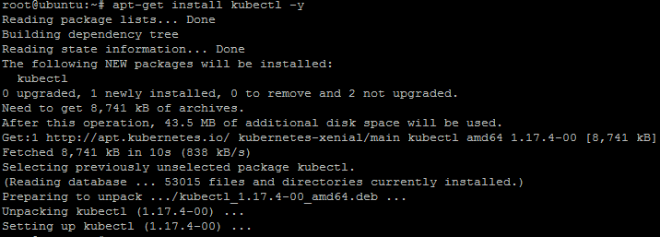

Once the Kubectl has been installed, you can check the version using the following command

kubectl version -o json

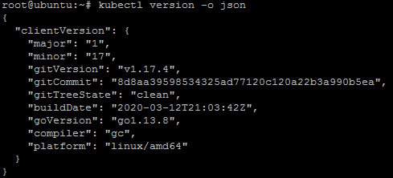
kubectl version –client
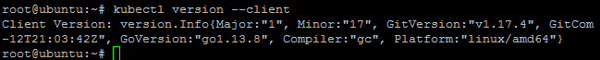
Start Minikube
minikube start

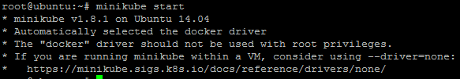
You can now check the cluster status with the following command:
kubectl cluster-info
You should see the following output:
Kubernetes master is running at https://192.168.99.100:8443
KubeDNS is running at https://192.168.99.100:8443/api/v1/namespaces/kube-system/services/kube-dns:dns/proxy

To further debug and diagnose cluster problems, use 'kubectl cluster-info dump'.
You can also check the Kubectl default configuration with the following command:
kubectl config view
You should see the following output:

apiVersion: v1
clusters:
- cluster:
certificate-authority: /root/.minikube/ca.crt
server: https://192.168.99.100:8443
name: minikube
contexts:
- context:
cluster: minikube
user: minikube
name: minikube
current-context: minikube
kind: Config
preferences: {}
users:
- name: minikube
user:
client-certificate: /root/.minikube/client.crt
client-key: /root/.minikube/client.key
To check the running nodes, run the following command:
kubectl get nodes
Output:
NAME STATUS ROLES AGE VERSION
minikube Ready master 2m45s v1.13.3
You can also access the Minikube Virtualbox with the following command:

minikube ssh

You should see the following output:

___ ___ (_) ___ (_)| |/') _ _ | |_ __
/' _ ` _ `\| |/' _ `\| || , < ( ) ( )| '_`\ /'__`\
| ( ) ( ) || || ( ) || || |\`\ | (_) || |_) )( ___/
(_) (_) (_)(_)(_) (_)(_)(_) (_)`\___/'(_,__/'`\____)

Now, exit from the Virtualbox shell:
$exit
You can also stop and delete kubernetes cluster anytime with the following command:
minikube stop
minikube delete
You can check the status of Minikube with the following command:
minikube status
Yo should see the following output:
host: Running
kubelet: Running
apiserver: Running
kubectl: Correctly Configured: pointing to minikube-vm at 192.168.99.100

https://www.howtoforge.com/how-to-install-kubernetes-with-minikube-on-ubuntu-1804-lts/
https://computingforgeeks.com/how-to-install-minikube-on-ubuntu-18-04/

How To Install Kubernetes Cluster On Ubuntu 16.04:-

Pre-requisites To Install Kubernetes
Since we are dealing with VMs, we recommend the following settings for the VMs:-
Master:
- 2 GB RAM
- 2 Cores of CPU
Slave/ Node:
- 1 GB RAM
- 1 Core of CPU
By this point of time, I have assumed you have 2 plain Ubuntu VMs imported onto your Oracle Virtual Box. So, I’l just get along with the installation process.

Pre-Installation Steps On Both Master & Slave (To Install Kubernetes)
The following steps have to be executed on both the master and node machines. Let’s call the the master as ‘kmaster‘ and node as ‘knode‘.

First, login as ‘sudo’ user because the following set of commands need to be executed with ‘sudo’ permissions. Then, update your ‘apt-get’ repository.
$ sudo su
# apt-get update
Note: After logging-in as ‘sudo’ user, note that your shell symbol will change to ‘#’ from ‘$’.

Turn Off Swap Space
Next, we have to turn off the swap space because Kubernetes will start throwing random errors otherwise. After that you need to open the ‘fstab’ file and comment out the line which has mention of swap partition.
# swapoff -a
# nano /etc/fstab
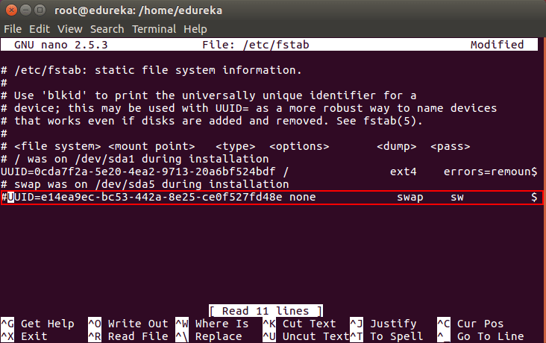
Then press ‘Ctrl+X’, then press ‘Y’ and then press ‘Enter’ to Save the file.

Update The Hostnames
To change the hostname of both machines, run the below command to open the file and subsequently rename the master machine to ‘kmaster’ and your node machine to ‘knode’.
# nano /etc/hostname
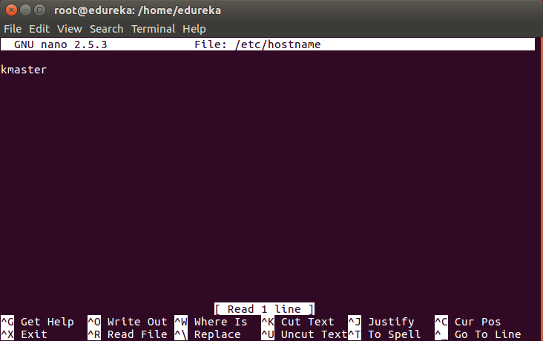
Then press ‘Ctrl+X’, then press ‘Y’ and then press ‘Enter’ to Save the file.

Update The Hosts File With IPs Of Master & Node
Run the following command on both machines to note the IP addresses of each.
# ifconfig
Make a note of the IP address from the output of the above command. The IP address which has to be copied should be under “enp0s8”, as shown in the screenshot below.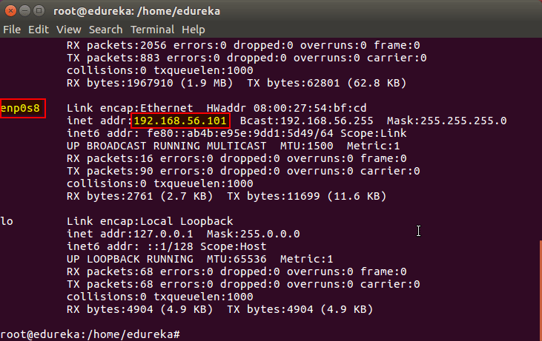
Now go to the ‘hosts’ file on both the master and node and add an entry specifying their respective IP addresses along with their names ‘kmaster’ and ‘knode’. This is used for referencing them in the cluster. It should look like the below screenshot on both the machines.
# nano /etc/hosts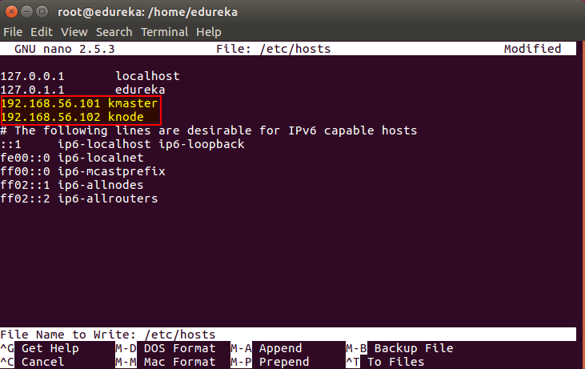
Then press ‘Ctrl+X’, then press ‘Y’ and then press ‘Enter’ to Save the file.

Setting Static IP Addresses
Next, we will make the IP addresses used above, static for the VMs. We can do that by modifying the network interfaces file. Run the following command to open the file:
# nano /etc/network/interfaces
Now enter the following lines in the file.
auto enp0s8
iface enp0s8 inet static
address <IP-Address-Of-VM>
It will look something like the below screenshot.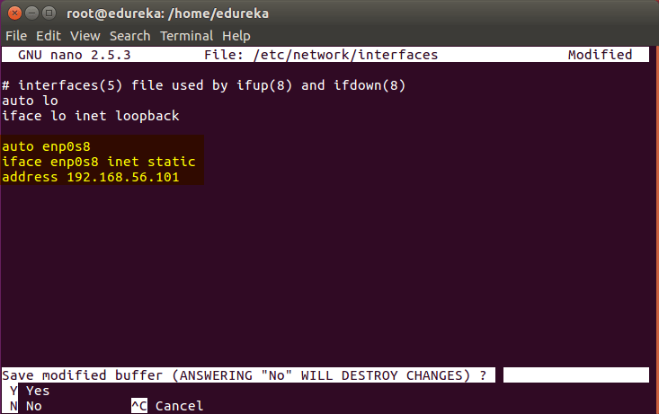
Then press ‘Ctrl+X’, then press ‘Y’ and then press ‘Enter’ to Save the file.
After this, restart your machine(s).

Install OpenSSH-Server
Now we have to install openshh-server. Run the following command:
# sudo apt-get install openssh-server

Install Docker
Now we have to install Docker because Docker images will be used for managing the containers in the cluster. Run the following commands:
# sudo su
# apt-get update
# apt-get install -y docker.io
Next we have to install these 3 essential components for setting up Kubernetes environment: kubeadm, kubectl, and kubelet.
Run the following commands before installing the Kubernetes environment.
# apt-get update && apt-get install -y apt-transport-https curl
# curl -s https://packages.cloud.google.com/apt/doc/apt-key.gpg | apt-key add -
# cat <<EOF >/etc/apt/sources.list.d/kubernetes.list
deb http://apt.kubernetes.io/ kubernetes-xenial main
EOF
# apt-get update

Install kubeadm, Kubelet And Kubectl
Now its time to install the 3 essential components. Kubelet is the lowest level component in Kubernetes. It’s responsible for what’s running on an individual machine. Kuebadm is used for administrating the Kubernetes cluster. Kubectl is used for controlling the configurations on various nodes inside the cluster.
# apt-get install -y kubelet kubeadm kubectl

Updating Kubernetes Configuration
Next, we will change the configuration file of Kubernetes. Run the following command:
# nano /etc/systemd/system/kubelet.service.d/10-kubeadm.conf
This will open a text editor, enter the following line after the last “Environment Variable”:
Environment=”cgroup-driver=systemd/cgroup-driver=cgroupfs”
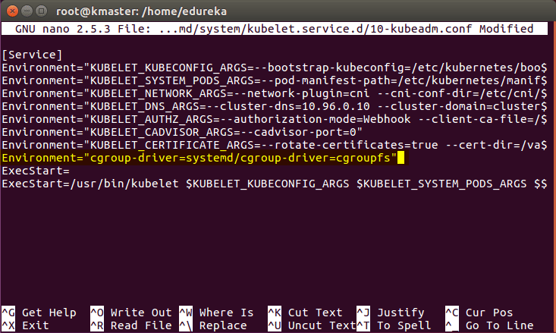
Now press Ctrl+X, then press Y, and then press Enter to Save.
Voila! You have successfully installed Kubernetes on both the machines now!
As of now, only the Kubernetes environment has been setup. But now, it is time to install Kubernetes completely, by moving onto the next 2 phases, where we will individually set the configurations in both machines.

Steps Only For Kubernetes Master VM (kmaster)
Note: These steps will only be executed on the master node (kmaster VM).
Step 1: We will now start our Kubernetes cluster from the master’s machine. Run the following command:
# kubeadm init --apiserver-advertise-address=<ip-address-of-kmaster-vm> --pod-network-cidr=192.168.0.0/16
- You will get the below output. The commands marked as (1), execute them as a non-root user. This will enable you to use kubectl from the CLI
- The command marked as (2) should also be saved for future. This will be used to join nodes to your cluster
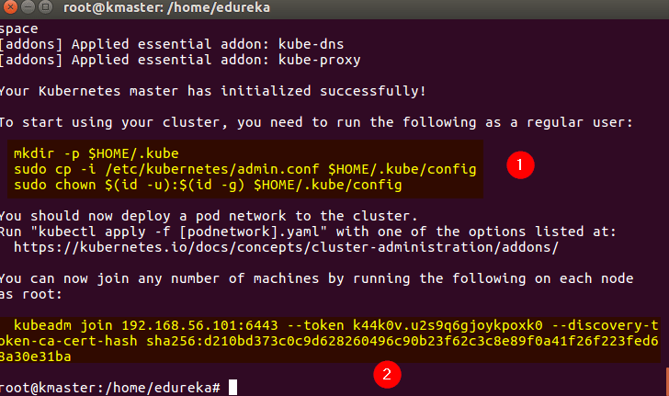
Step 2: As mentioned before, run the commands from the above output as a non-root user
$ mkdir -p $HOME/.kube
$ sudo cp -i /etc/kubernetes/admin.conf $HOME/.kube/config
$ sudo chown $(id -u):$(id -g) $HOME/.kube/config
It should look like this:
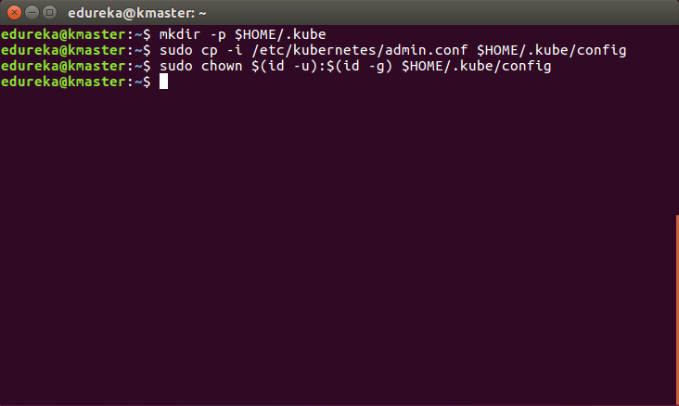
To verify, if kubectl is working or not, run the following command:
$ kubectl get pods -o wide --all-namespaces
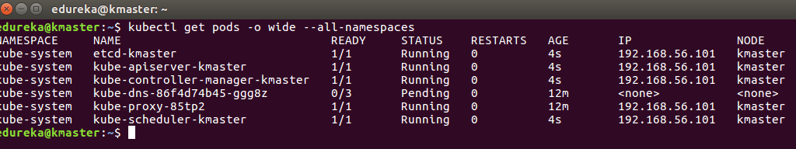
Next
Step 3: You will notice from the previous command, that all the pods are running except one: ‘kube-dns’. For resolving this we will install a pod network. To install the CALICO pod network, run the following command:
$ kubectl apply -f https://docs.projectcalico.org/v3.0/getting-started/kubernetes/installation/hosted/kubeadm/1.7/calico.yaml
After some time, you will notice that all pods shift to the running state
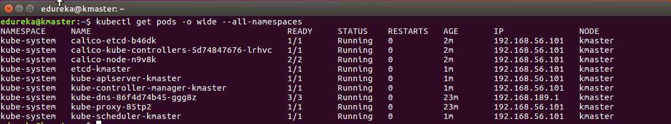
Step 4: Next, we will install the dashboard. To install the Dashboard, run the following command:
$ kubectl create -f https://raw.githubusercontent.com/kubernetes/dashboard/master/src/deploy/recommended/kubernetes-dashboard.yaml
It will look something like this:
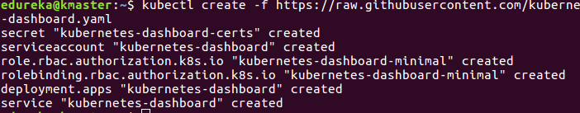
Step 5: Your dashboard is now ready with it’s the pod in the running state.
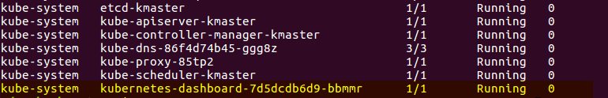
Step 6: By default dashboard will not be visible on the Master VM. Run the following command in the command line:
$ kubectl proxy
Then you will get something like this:
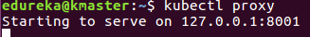
To view the dashboard in the browser, navigate to the following address in the browser of your Master VM: http://localhost:8001/api/v1/namespaces/kube-system/services/https:kubernetes-dashboard:/proxy/
You will then be prompted with this page, to enter the credentials:
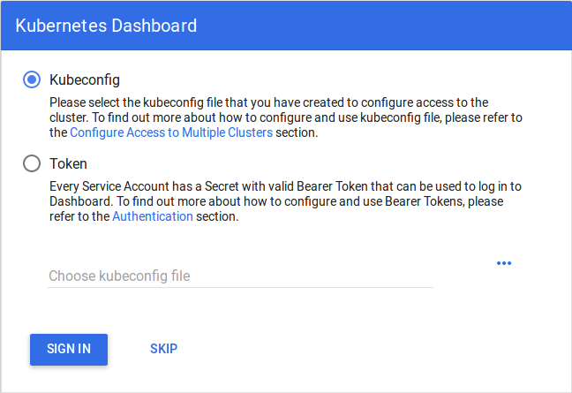
Step 7: In this step, we will create the service account for the dashboard and get it’s credentials.
Note: Run all these commands in a new terminal, or your kubectl proxy command will stop.
Run the following commands:
1. This command will create a service account for dashboard in the default namespace
$ kubectl create serviceaccount dashboard -n default
2. This command will add the cluster binding rules to your dashboard account
$ kubectl create clusterrolebinding dashboard-admin -n default
--clusterrole=cluster-admin
--serviceaccount=default:dashboard
3. This command will give you the token required for your dashboard login
$ kubectl get secret $(kubectl get serviceaccount dashboard -o jsonpath="{.secrets[0].name}") -o jsonpath="{.data.token}" | base64 --decode
You should get the token like this:
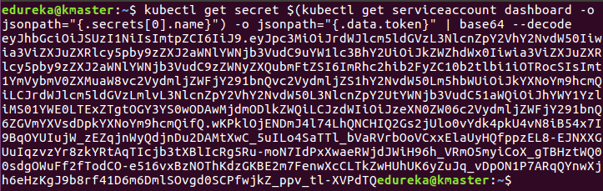
4. Copy this token and paste it in Dashboard Login Page, by selecting token option
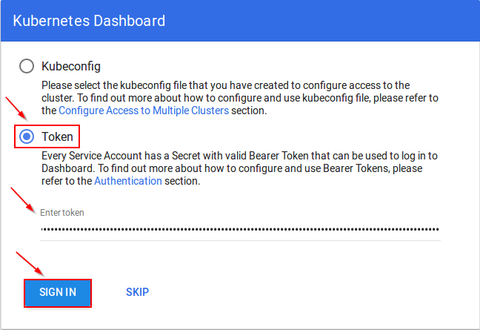
5. You have successfully logged into your dashboard!
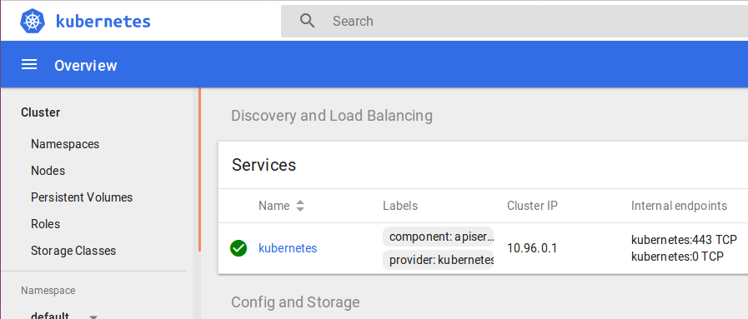

Steps For Only Kubernetes Node VM (knode)
It is time to get your node, to join the cluster! This is probably the only step that you will be doing on the node, after installing kubernetes on it.
Run the join command that you saved, when you ran ‘kubeadm init’ command on the master.Note: Run this command with “sudo”.
sudo kubeadm join --apiserver-advertise-address=<ip-address-of-the master> --pod-network-cidr=192.168.0.0/16
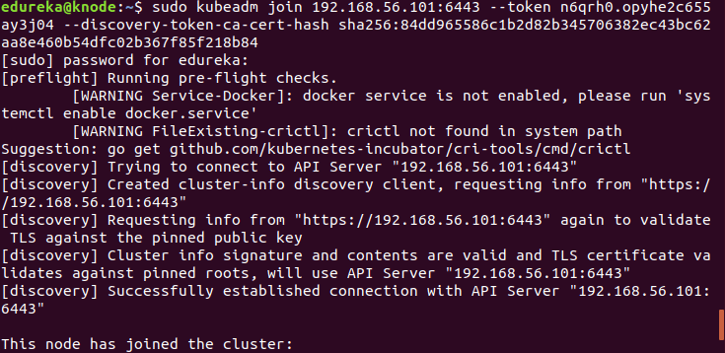
Using kubectl to Create a Deployment :-

Kubernetes Clusters
Kubernetes coordinates a highly available cluster of computers that are connected to work as a single unit. The abstractions in Kubernetes allow you to deploy containerized applications to a cluster without tying them specifically to individual machines. To make use of this new model of deployment, applications need to be packaged in a way that decouples them from individual hosts: they need to be containerized. Containerized applications are more flexible and available than in past deployment models, where applications were installed directly onto specific machines as packages deeply integrated into the host. Kubernetes automates the distribution and scheduling of application containers across a cluster in a more efficient way. Kubernetes is an open-source platform and is production-ready.
A Kubernetes cluster consists of two types of resources:
- The Master coordinates the cluster
- Nodes are the workers that run applications

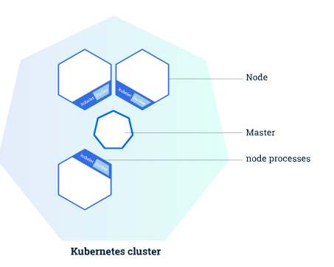
The following are typical use cases for Deployments:
- Create a Deployment to rollout a ReplicaSet. The ReplicaSet creates Pods in the background. Check the status of the rollout to see if it succeeds or not.
- Declare the new state of the Pods by updating the PodTemplateSpec of the Deployment. A new ReplicaSet is created and the Deployment manages moving the Pods from the old ReplicaSet to the new one at a controlled rate. Each new ReplicaSet updates the revision of the Deployment.
- Rollback to an earlier Deployment revision if the current state of the Deployment is not stable. Each rollback updates the revision of the Deployment.
- Scale up the Deployment to facilitate more load.
- Pause the Deployment to apply multiple fixes to its PodTemplateSpec and then resume it to start a new rollout.
- Use the status of the Deployment as an indicator that a rollout has stuck.
- Clean up older ReplicaSets that you don’t need anymore.

Creating a Deployment
The following is an example of a Deployment. It creates a ReplicaSet to bring up three nginx Pods:
controllers/nginx-deployment.yaml

apiVersion: apps/v1
kind: Deployment
metadata:
name: nginx-deployment
labels:
app: nginx
spec:
replicas: 3
selector:
matchLabels:
app: nginx
template:
metadata:
labels:
app: nginx
spec:
containers:
- name: nginx
image: nginx:1.7.9
ports:
- containerPort: 80

In this example:
- A Deployment named nginx-deployment is created, indicated by the .metadata.name field.
- The Deployment creates three replicated Pods, indicated by the replicas field.
- The selector field defines how the Deployment finds which Pods to manage. In this case, you simply select a label that is defined in the Pod template (app: nginx). However, more sophisticated selection rules are possible, as long as the Pod template itself satisfies the rule.
The template field contains the following sub-fields:
- The Pods are labeled app: nginxusing the labels field.
- The Pod template’s specification, or .template.spec field, indicates that the Pods run one container, nginx, which runs the nginx Docker Hub image at version 1.7.9.
- Create one container and name it nginx using the name field.

1 - Create the Deployment by running the following command:

kubectl apply -f https://k8s.io/examples/controllers/nginx-deployment.yaml

2 - Run kubectl get deployments to check if the Deployment was created. If the Deployment is still being created, the output is similar to the following:

NAME READY UP-TO-DATE AVAILABLE AGE
nginx-deployment 0/3 0 0 1s

When you inspect the Deployments in your cluster, the following fields are displayed:
- NAME lists the names of the Deployments in the cluster.
- DESIRED displays the desired number of replicas of the application, which you define when you create the Deployment. This is the desired state.
- CURRENT displays how many replicas are currently running.
- UP-TO-DATE displays the number of replicas that have been updated to achieve the desired state.
- AVAILABLE displays how many replicas of the application are available to your users.
- AGE displays the amount of time that the application has been running.
Notice how the number of desired replicas is 3 according to .spec.replicas field.

3 - To see the Deployment rollout status, run kubectl rollout status deployment.v1.apps/nginx-deployment. The output is similar to this:
Waiting for rollout to finish: 2 out of 3 new replicas have been updated...
deployment.apps/nginx-deployment successfully rolled out

4 - Run the kubectl get deployments again a few seconds later. The output is similar to this:

NAME READY UP-TO-DATE AVAILABLE AGE
nginx-deployment 3/3 3 3 18s

Notice that the Deployment has created all three replicas, and all replicas are up-to-date (they contain the latest Pod template) and available.

5 - To see the ReplicaSet (rs) created by the Deployment, run kubectl get rs. The output is similar to this:

NAME DESIRED CURRENT READY AGE
nginx-deployment-75675f5897 3 3 3 18s

6 - To see the labels automatically generated for each Pod, run kubectl get pods --show-labels. The following output is returned:

NAME READY STATUS RESTARTS AGE LABELS
nginx-deployment-75675f5897-7ci7o 1/1 Running 0 18s app=nginx,pod-template-hash=3123191453
nginx-deployment-75675f5897-kzszj 1/1 Running 0 18s app=nginx,pod-template-hash=3123191453
nginx-deployment-75675f5897-qqcnn 1/1 Running 0 18s app=nginx,pod-template-hash=3123191453

Updating a Deployment : -

1 - Let’s update the nginx Pods to use the nginx:1.9.1 image instead of the nginx:1.7.9 image.

kubectl --record deployment.apps/nginx-deployment set image deployment.v1.apps/nginx-deployment nginx=nginx:1.9.1

or simply use the following command:

kubectl set image deployment/nginx-deployment nginx=nginx:1.9.1 --record

The output is similar to this:
deployment.apps/nginx-deployment image updated

Alternatively, you can edit the Deployment and change
.spec.template.spec.containers[0].image from nginx:1.7.9 to nginx:1.9.1:
kubectl edit deployment.v1.apps/nginx-deployment
The output is similar to this:
deployment.apps/nginx-deployment edited

To see the rollout status, run:
kubectl rollout status deployment.v1.apps/nginx-deployment
The output is similar to this:
Waiting for rollout to finish: 2 out of 3 new replicas have been updated...
Or

deployment.apps/nginx-deployment successfully rolled out

- Run kubectl get rs to see that the Deployment updated the Pods by creating a new ReplicaSet and scaling it up to 3 replicas, as well as scaling down the old ReplicaSet to 0 replicas.
kubectl get rs
The output is similar to this:
NAME DESIRED CURRENT READY AGE
nginx-deployment-1564180365 3 3 3 6s
nginx-deployment-2035384211 0 0 0 36s
- Running get pods should now show only the new Pods:
kubectl get pods
The output is similar to this:
NAME READY STATUS RESTARTS AGE
nginx-deployment-1564180365-khku8 1/1 Running 0 14s
nginx-deployment-1564180365-nacti 1/1 Running 0 14s
nginx-deployment-1564180365-z9gth 1/1 Running 0 14s

Get details of your Deployment:

kubectl describe deployments

Name: nginx-deployment
Namespace: default
CreationTimestamp: Thu, 30 Nov 2017 10:56:25 +0000
Labels: app=nginx
Annotations: deployment.kubernetes.io/revision=2
Selector: app=nginx
Replicas: 3 desired | 3 updated | 3 total | 3 available | 0 unavailable
StrategyType: RollingUpdate
MinReadySeconds: 0
RollingUpdateStrategy: 25% max unavailable, 25% max surge
Pod Template:
Labels: app=nginx
Containers:
nginx:
Image: nginx:1.9.1
Port: 80/TCP
Environment: <none>
Mounts: <none>
Volumes: <none>
Conditions:
Type Status Reason
---- ------ ------
Available True MinimumReplicasAvailable
Progressing True NewReplicaSetAvailable
OldReplicaSets: <none>
NewReplicaSet: nginx-deployment-1564180365 (3/3 replicas created)

Rolling Back a Deployment :-

Suppose that you made a typo while updating the Deployment, by putting the image name as nginx:1.91 instead of nginx:1.9.1:

kubectl set image deployment.v1.apps/nginx-deployment nginx=nginx:1.91 --record=true

- The output is similar to this:
- deployment.apps/nginx-deployment image updated
- The rollout gets stuck. You can verify it by checking the rollout status:
kubectl rollout status deployment.v1.apps/nginx-deployment
The output is similar to this:
Waiting for rollout to finish: 1 out of 3 new replicas have been updated...

kubectl get rs
The output is similar to this:
NAME DESIRED CURRENT READY AGE
nginx-deployment-1564180365 3 3 3 25s
nginx-deployment-2035384211 0 0 0 36s
nginx-deployment-3066724191 1 1 0 6s
Looking at the Pods created, you see that 1 Pod created by new ReplicaSet is stuck in an image pull loop.
kubectl get pods
The output is similar to this:
NAME READY STATUS RESTARTS AGE
nginx-deployment-1564180365-70iae 1/1 Running 0 25s
nginx-deployment-1564180365-jbqqo 1/1 Running 0 25s
nginx-deployment-1564180365-hysrc 1/1 Running 0 25s
nginx-deployment-3066724191-08mng 0/1 ImagePullBackOff 0 6s

Note: The Deployment controller stops the bad rollout automatically, and stops scaling up the new ReplicaSet. This depends on the rollingUpdate parameters (maxUnavailable specifically) that you have specified. Kubernetes by default sets the value to 25%.

Rolling Back to a Previous Revision –

kubectl rollout undo deployment.v1.apps/nginx-deployment

Scaling a Deployment :-
You can scale a Deployment by using the following command:
kubectl scale deployment.v1.apps/nginx-deployment --replicas=10
The output is similar to this:
deployment.apps/nginx-deployment scaled

Assuming horizontal Pod autoscaling is enabled in your cluster, you can setup an autoscaler for your Deployment and choose the minimum and maximum number of Pods you want to run based on the CPU utilization of your existing Pods.

kubectl autoscale deployment.v1.apps/nginx-deployment --min=10 --max=15 --cpu-percent=80

Pausing and Resuming a Deployment :-
You can pause a Deployment before triggering one or more updates and then resume it. This allows you to apply multiple fixes in between pausing and resuming without triggering unnecessary rollouts.

Pause by running the following command:
kubectl rollout pause deployment.v1.apps/nginx-deployment
The output is similar to this:
deployment.apps/nginx-deployment paused

Then update the image of the Deployment:
kubectl set image deployment.v1.apps/nginx-deployment nginx=nginx:1.9.1
The output is similar to this:
deployment.apps/nginx-deployment image updated

Eventually, resume the Deployment and observe a new ReplicaSet coming up with all the new updates:
kubectl rollout resume deployment.v1.apps/nginx-deployment
The output is similar to this:
deployment.apps/nginx-deployment resumed

Expose the Pod to the public internet using the kubectl expose command:
kubectl expose deployment hello-node --type=LoadBalancer --port=8080

delete a deployment in Kubernetes-
- If you’ve created your deployment from a file, you can use kubectl delete -f deployment.yaml to delete your deployment
- If you’ve created your deployment from the command line, you can use kubectl delete deployment my-deployment to delete your deployment
Introduction
Kubernetes is an open source platform for managing container technologies such as Docker.
Docker lets you create containers for a pre-configured image and application. Kubernetes provides the next step, allowing you to balance loads between containers and run multiple containers across multiple systems.
This guide will walk you through how to install Kubernetes on Ubuntu 18.04.
Prerequisites
- 2 or more Linux servers running Ubuntu 18.04
- Access to a user account on each system with sudo or root privileges
- The apt package manager, included by default
- Command-line/terminal window (Ctrl-Alt-T)

Steps to Install Kubernetes on Ubuntu

Set up Docker

Step 1: Install Docker
Kubernetes requires an existing Docker installation. If you already have Docker installed, skip ahead to Step 2.
If you do not have Kubernetes, install it by following these steps:
1. Update the package list with the command:
sudo apt-get update
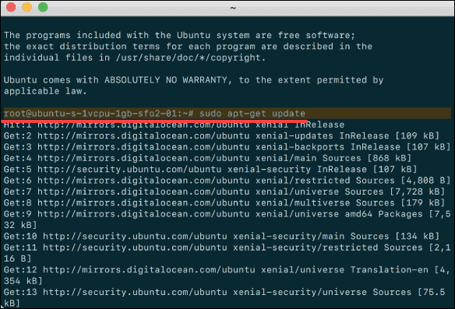
2. Next, install Docker with the command:
sudo apt-get install docker.io
3. Repeat the process on each server that will act as a node.
4. Check the installation (and version) by entering the following:
docker ––version

Step 2: Start and Enable Docker
1. Set Docker to launch at boot by entering the following:
sudo systemctl enable docker
2. Verify Docker is running:
sudo systemctl status docker
To start Docker if it’s not running:
sudo systemctl start docker
3. Repeat on all the other nodes.

Install Kubernetes

Step 3: Add Kubernetes Signing Key
Since you are downloading Kubernetes from a non-standard repository, it is essential to ensure that the software is authentic. This is done by adding a signing key.
1. Enter the following to add a signing key:
curl -s https://packages.cloud.google.com/apt/doc/apt-key.gpg | sudo apt-key add
If you get an error that curl is not installed, install it with:
sudo apt-get install curl
2. Then repeat the previous command to install the signing keys. Repeat for each server node.

Step 4: Add Software Repositories
Kubernetes is not included in the default repositories. To add them, enter the following:
sudo apt-add-repository "deb http://apt.kubernetes.io/ kubernetes-xenial main"
Repeat on each server node.

Step 5: Kubernetes Installation Tools
Kubeadm (Kubernetes Admin) is a tool that helps initialize a cluster. It fast-tracks setup by using community-sourced best practices. Kubelet is the work package, which runs on every node and starts containers. The tool gives you command-line access to clusters.
1. Install Kubernetes tools with the command:
sudo apt-get install kubeadm kubelet kubectl
sudo apt-mark hold kubeadm kubelet kubectl
Allow the process to complete.
2. Verify the installation with:
kubeadm version
3. Repeat for each server node.

Note: Make sure you install the same version of each package on each machine. Different versions can create instability. Also, this process prevents apt from automatically updating Kubernetes. For update instructions, please see the developers’ instructions.

Kubernetes Deployment

Step 6: Begin Kubernetes Deployment
Start by disabling the swap memory on each server:
sudo swapoff –a

Step 7: Assign Unique Hostname for Each Server Node
Decide which server to set as the master node. Then enter the command:
sudo hostnamectl set-hostname master-node
Next, set a worker node hostname by entering the following on the worker server:
sudo hostnamectl set-hostname worker01
If you have additional worker nodes, use this process to set a unique hostname on each.

Step 8: Initialize Kubernetes on Master Node
Switch to the master server node, and enter the following:
sudo kubeadm init --pod-network-cidr=10.244.0.0/16
Once this command finishes, it will display a kubeadm join message at the end. Make a note of the whole entry. This will be used to join the worker nodes to the cluster.
Next, enter the following to create a directory for the cluster:
kubernetes-master:~$ mkdir -p $HOME/.kube
kubernetes-master:~$ sudo cp -i /etc/kubernetes/admin.conf $HOME/.kube/config
kubernetes-master:~$ sudo chown $(id -u):$(id -g) $HOME/.kube/config

Step 9: Deploy Pod Network to Cluster
A Pod Network is a way to allow communication between different nodes in the cluster. This tutorial uses the flannel virtual network.
Enter the following:
sudo kubectl apply -f https://raw.githubusercontent.com/coreos/flannel/master/Documentation/kube-flannel.yml
Allow the process to complete.
Verify that everything is running and communicating:
kubectl get pods --all-namespaces

Step 10: Join Worker Node to Cluster
As indicated in Step 7, you can enter the kubeadm join command on each worker node to connect it to the cluster.
Switch to the worker01 system and enter the command you noted from Step 7:
kubeadm join --discovery-token abcdef.1234567890abcdef --discovery-token-ca-cert-hash sha256:1234..cdef 1.2.3.4:6443
Replace the alphanumeric codes with those from your master server. Repeat for each worker node on the cluster. Wait a few minutes; then you can check the status of the nodes.
Switch to the master server, and enter:
kubectl get nodes
The system should display the worker nodes that you joined to the cluster.

